**Image Classification Using Convolutional Neural Networks (CNN)**

This project demonstrates how to build and train a Convolutional Neural Network (CNN) to classify images from the CIFAR-10 dataset into different categories such as airplanes, cars, birds, cats, deer, dogs, frogs, horses, ships, and trucks.

**Project Features**

* **Data Augmentation**: Implemented techniques like random flipping and rotation to improve model generalization.
* **Model Architecture**:
  + Input layer for images of size 32x32x3.
  + Two convolutional layers with ReLU activation followed by max pooling.
  + A fully connected dense layer with dropout for regularization.
  + Output layer using a softmax activation function for classification into 10 categories.
* **Frameworks Used**: TensorFlow and Keras for model building and training.
* **Visualization**: Training and validation accuracy/loss plotted for performance analysis.

**Dataset**

The project uses the CIFAR-10 dataset, a well-known dataset of 60,000 32x32 color images divided into 10 classes, with 6,000 images per class.

**Prerequisites**

Ensure the following are installed:

* Python 3.7+
* TensorFlow
* Matplotlib

**Project Workflow**

1. Load and preprocess CIFAR-10 dataset.
2. Apply data augmentation for better generalization.
3. Build a CNN model.
4. Train the model and evaluate it on test data.
5. Visualize accuracy and loss trends over epochs.

**Results**

The model achieved an accuracy of approximately 65% on the test dataset. Additional tuning or advanced techniques could further improve performance.

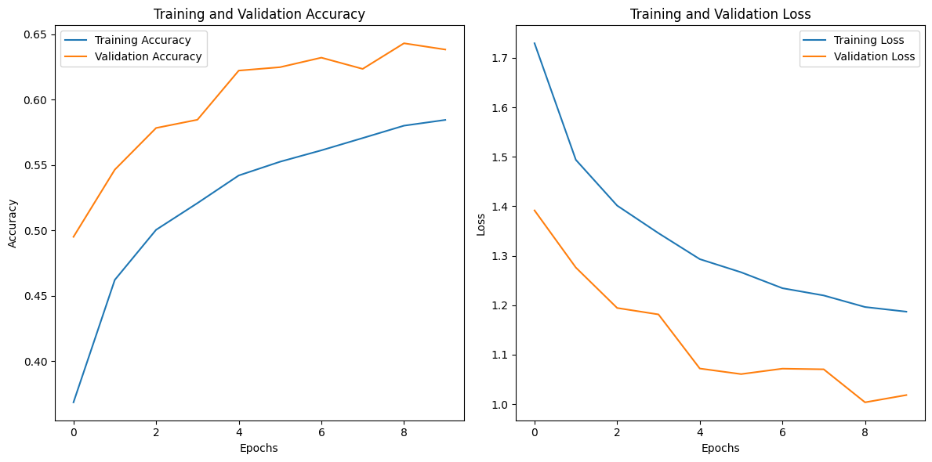

**Future Enhancements**

* Implement additional data augmentation techniques.
* Use transfer learning with pre-trained models like ResNet or VGG.
* Optimize hyperparameters for better accuracy.